2020 AVQA Quilt Show
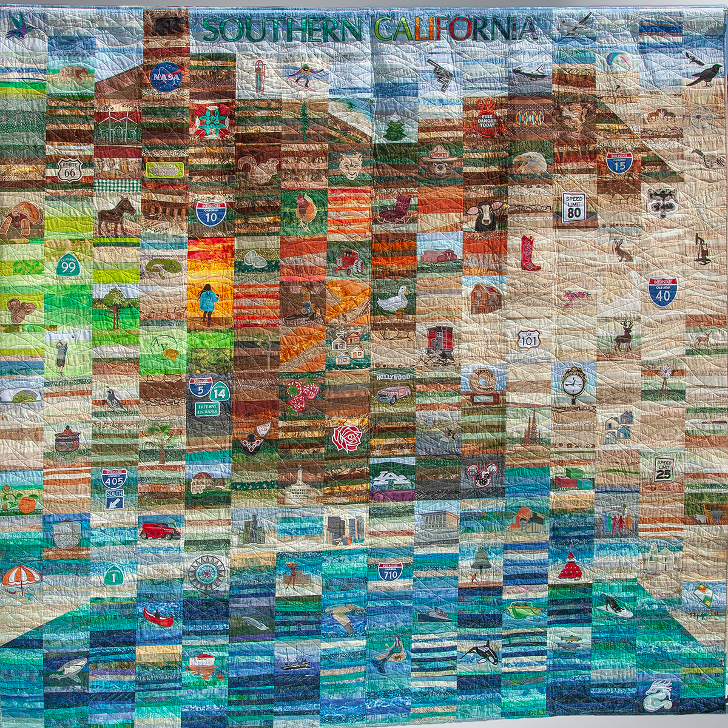
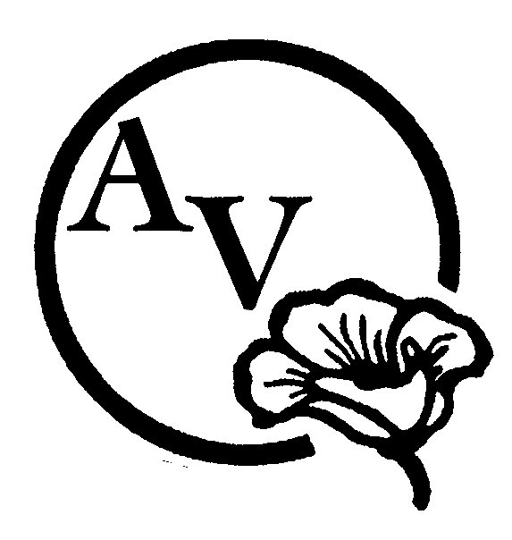

“Glorious Southern California” ”

ENTRANT’s NAME:

Phone Number: Email:

Quilt Title:

Pattern name and/or source:

Size: (Width x Length in inches): Year Completed:

Made by: one person two person group

Is this your first time entering a quilt in AVQA? ☐ Yes ☐ No

Construction Technique: Choose one item.

Quilting Technique: Choose one item.

Quilted by:

Quilt available for purchase? ☐ Yes ☐ No Asking Price:
Comments: Please delete these instructions in red when you write a paragraph and tell us about your quilt! Where did you find the pattern or inspiration? What techniques did you use: What type of thread, batting or embellishment did you use? Does this quilt have a story? What would you like to tell the person who is looking at your quilt?

I have read and understand the Quilt Show Entry Rules. I also understand that liability insurance is the sole responsibility of the entrant. If offering my quilt for sale, I acknowledge that the guild will receive 10% of the asking price.

SIGNATURE OF ENTRANT*: ___________________________________DATE: ___________________
* Signature not required if submitted electronically – email transmission will signify agreement.
EMAIL FORM TO: Karenstenback@gmail.com or Jamie Harrington at jharrington66@earthlink.net *******************************************
To be completed by AVQA:

QUILT NUMBER: ________________ JUDGING CATEGORY: ___________________________________________
2019 AVQA QUILT SHOW ENTRY RULES & JUDGING GUIDELINES

1. AVQA MEMBERS current as of January 1, 2020 may enter quilts for judging or exhibition only. AVQA MEMBERS who join after January 1, 2020 may enter quilts for exhibition only.
2. Quilts judged in previous AVQA shows cannot be entered again, except by invitation or exhibition, only.
3. Entrant must be the maker of the entry to be judged or approved as ‘special circumstance.’
4. Multiple entries by the same entrant will be hung as space permits.
5. Each quilt entry requires a separate entry form with a photograph attached. The photograph may be of a quilt in progress (unfinished). Photo can be taken at the April meeting during the break.
6. DEADLINE FOR REGISTRATION IS THURSDAY, APRIL 9th. Entry forms will be published in the newsletter and electronic forms will be on the AVQA website. Forms will also be available at Guild meetings. WE NEED YOUR ENTRY FORMS BY APRIL 9TH TO ALLOW US TIME TO PREPARE THE SPREADSHEET, LEGENDS & PROGRAM.
7. Quilts must be finished, clean, and free of odors and pet hair.
8. A four-inch sleeve is required on all quilts except small quilts. Quilts wider than 110 inches cannot be hung on AVQA quilt stands unless folded and draped over the rod.
9. Quilts must have a label sewn on the back with entrant's & quilt's name. Names will be covered for judging.
10. Quilts that are to be judged must be delivered to the Antelope Valley Fair Grounds Friday, May 15, between 8:00 & 9:45 a.m. Exhibit Only quilts may be delivered between 8:00 a.m. & 2:00 p.m. Receipts will be provided with each entry. Alternate check-in arrangements may be made by contacting Sandy Smith or Karen Stenback.
11. The facility will be closed during the "take down" process of the show to all except to those who are working.
12. Quilts may be picked up at the checkout station between 5:00 p.m. and 6:00 p.m. on Sunday, May 17. BRING IDENTIFICATION. For security purposes, entries may only be removed from the facility through the checkout station.

JUDGED QUILTS
GUIDELINES: Judges reserve the right to move, split, or combine categories dependent on number of entries received.

SIZES: Wall (Small) Quilt: Maximum of 40 inches on one side; (this does not include table runners, which are in the Applied Art category). Medium: maximum of 60 inches in width and 80 inches in length; Large: Minimum of 80 inches in width and 90 inches in length.

One Person: Must be made by one individual entirely, including pieced, quilted, bound.
Two Person: Must be the work of two persons (one may do the piecing and one may do the quilting).
Group: Three or more persons must have been involved in the assembly and quilting of the piece.
Examples are round robin, block exchange or made by a friendship circle. Can be any technique.

ART QUILT: Mixed media or fiber art. Art form that uses both modern and traditional quilting techniques to create art objects- “a creative work that is layered and stitched or references a form of stitched layered structure.”

PIECED QUILT: A quilt is considered to be pieced if the piecing is predominant over all other techniques.

APPLIQUÉD QUILT: A quilt is considered to be appliqued if the main technique (50% or more) of the quilt top is applique’. Other techniques may be used, but must support the main technique, which is applique’.

MINIATURE QUILT: A traditional quilt pattern that is one-twelfth (1/12) the size of the standard quilt pattern. A normal 12" finished block will be 1" in Miniature.

BALANCED PIECING & APPLIQUÉ: A combination of appliqué and piecing techniques are used to form the quilt top. Both
techniques must contribute to the over-all design. The quilt must contain a noticeable & significant amount of both.

MODERN QUILT: A 'modern quilt' is a quilt inspired by modern design, including some of the following characteristics: the use of bold colors and prints, high contrast and graphic areas of solid color, improvisational piecing, minimalism, expansive negative space, and alternate grid work; can include 'modern traditionalism or the updating of classic quilt designs.

KIT QUILTS AND BLOCK OF THE MONTH: These quilts are packaged in kit form with additional fabrics or embellishments provided by the maker. They may be put together by one person and quilted by another. They may be any size or technique.

SPECIALTY TECHNIQUES: Machine or hand quilted entries using predominantly specialty techniques such as cross stitch, embroidery including redwork, stenciling, painting, trapunto, whole cloth, crazy quilting, cathedral window, yo-yo, and rag quilts. This includes quilts that do not fit into the Applique or Pieced categories, and include quilts made using innovative techniques of construction, design and embellishment such as used in pictorial quilts, abstract quilts, snippets, collage, and quilts of original design using innovative piecing or applique techniques.

APPLIED ARTS: Wearable art, pillows, placemats, table runners, tree skirts, Christmas stockings, sewing machine covers, and tea cozies, etc. The item must contain recognizable quilting.

SPECIAL AWARDS:
Quilting: Best Stationary machine quilting; Best moveable machine quilting; Best programmed machine quilting; Best hand quilting
Best of Show: The piece that is the best example of quilt making in all of the entries submitted
First Time Entrant in an AVQA show
Judge’s Choice

* If you have questions regarding categories, contact Karen Stenback at karenstenback@gmail.com, or call/text t 661-466-7988.

