2017 AVQA Quilt Show
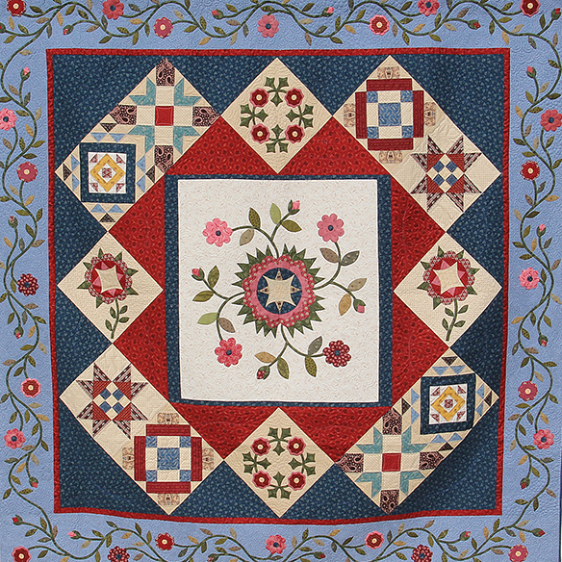
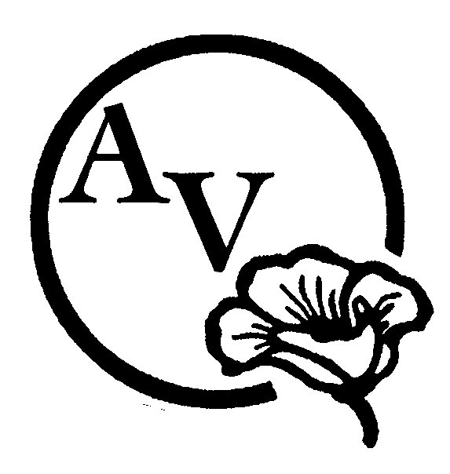

“Ruby Jubilee”

ENTRANT’s NAME:

Quilt Title:

Pattern name and/or source:

Size: (Width x Length in inches): Year Completed:

Judging Category: Choose an item. Size Category: Choose an item.

Construction Technique: Choose an item.

Quilting Technique: Choose an item.

Quilted by:

Quilt available for purchase? ☐ Yes ☐ No
Asking Price:

Comments: Please delete these instructions in red when you write a paragraph and tell us about your quilt! Where did you find the pattern or inspiration? What techniques did you use: What type of thread, batting or embellishment did you use? Does this quilt have a story? What would you like to tell the person who is looking at your quilt?

I have read and understand the Quilt Show Entry Rules. I also understand that liability insurance is the sole responsibility of the entrant. If offering my quilt for sale, I acknowledge that the guild will receive 10% of the asking price.

SIGNATURE OF ENTRANT*: ___________________________________DATE: ___________________
* signature not required if submitted electronically – email transmission will signify agreement.

******************************************************************************************************
To be completed by AVQA:

QUILT NUMBER: ________________ JUDGING CATEGORY: ___________________________________________

2017 AVQA QUILT SHOW ENTRY RULES & JUDGING GUIDELINES

1. AVQA MEMBERS may enter quilts for judging or for exhibition. NON AVQA MEMBERS may enter for exhibition only as space permits for a fee of $15.00.
2. Quilts judged in previous AVQA shows cannot be entered again, except by invitation or exhibition, only.
3. Entrant must be the maker of the entry to be judged.
4. Multiple entries by the same entrant will be hung as space permits.
5. Each quilt entry requires a separate entry form with a photograph attached. The photograph may be of a quilt in progress (unfinished). Photo can be taken at the April meeting during the break.
6. DEADLINE FOR REGISTRATION IS THURSDAY, MAY 4th. Entry forms will be published in the newsletter and electronic forms will be on the AVQA website. Forms will also be available at Guild meetings. WE NEED YOUR ENTRY FORMS BY MAY 4TH.
7. Quilts must be finished, clean, and free of odors and pet hair.
8. A four-inch sleeve is required on all quilts except small quilts. Quilts wider than 110 inches cannot be hung on AVQA quilt stands unless folded and draped over the rod.
9. All quilts should have a cloth label sewn on the back. The entrant's name and the quilt's name should be included. Names on the quilts will be covered during judging.
10. Quilts that are to be judged must be delivered to the Lancaster United Methodist Church, 918 West Avenue J, Lancaster on Thursday, June 1st, 2017, between the hours of 8:00 a.m. and 10:00 a.m. only. Exhibit Only quilts may be delivered during that time or to the Antelope Valley Fair Grounds Friday, June 2nd, between 10:00 a.m. and 2:00 p.m. Receipts will be provided with each entry. Alternate check-in arrangements may be made by contacting Sue Jacobsen.
11. The facility will be closed during the "take down" process of the show to all except those who are working.
12. Quilts may be picked up at the checkout station between 5:00 p.m. and 6:00 p.m. on Sunday, June 4th, 2017. BRING YOUR RECEIPT. For security purposes, entries may only be removed from the facility through the checkout station.

JUDGED QUILTS

GUIDELINES: Small/Medium = up to 48 inches wide; Large = 49 inches wide and above. Judges reserve the right to move, split, or combine categories dependent on number of entries received.

PIECED QUILT: A quilt is considered to be pieced if the piecing is predominant over all other techniques.

APPLIQUED QUILT: A quilt is considered to be machine appliqued if both machine and hand applique techniques are used. A quilt is considered to be hand appliqued when ALL of the applique work is done by hand.

MODERN QUILT: A 'modern quilt' is a quilt inspired by modern design, including some of the following characteristics: the use of bold colors and prints, high contrast and graphic areas of solid color, improvisational piecing, minimalism, expansive negative space, and alternate grid work; can include 'modern traditionalism or the updating of classic quilt designs.

GROUP QUILT: A quilt with a top that has been constructed by two or more people. Examples of this type of quilt are round robin, block exchange, or a quilt made by a friendship circle.

SPECIALTY TECHNIQUES: Machine or hand quilted entries using predominantly specialty techniques such as cross stitch, embroidery including redwork, stenciling, painting, trapunto, whole cloth, crazy quilting, cathedral window, yo-yo, and rag quilts. This includes quilts that do not fit into the Applique or Pieced categories, and include quilts made using innovative techniques of construction, design and embellishment such as used in pictorial quilts, abstract quilts, Snippets, and quilts of original design using innovative piecing or applique techniques.

WEARABLE ART/OTHER Wearable Art: the piece must be intended to be worn as a garment or fashion accessory, i.e., hat, belt, purse, vest, scarf. The item must contain recognizable quilting. Other: this can include quilted items such as pillows, placemats, table runners, dolls and other stitched toys, tree skirts, Christmas stockings, sewing machine covers, and tea cozies.

FIRST TIME ENTRANT: This is the first time the member has entered a quilt for judging in an AVQA quilt show.

BEST HAND QUILTING: Must be submitted for judging by the person who did the hand quilting.

BEST MACHINE QUILTING ON DOMESTIC MACHINE BY ENTRANT: Must be submitted by the person who did the quilting.

BEST MACHINE QUILTING ON LONGARM BY ENTRANT: Must be submitted by the person who did the quilting.

BEST MACHINE QUILTING BY PROFESSIONAL: Must be submitted by the person who did the quilting.

