2019 AVQA Quilt Show
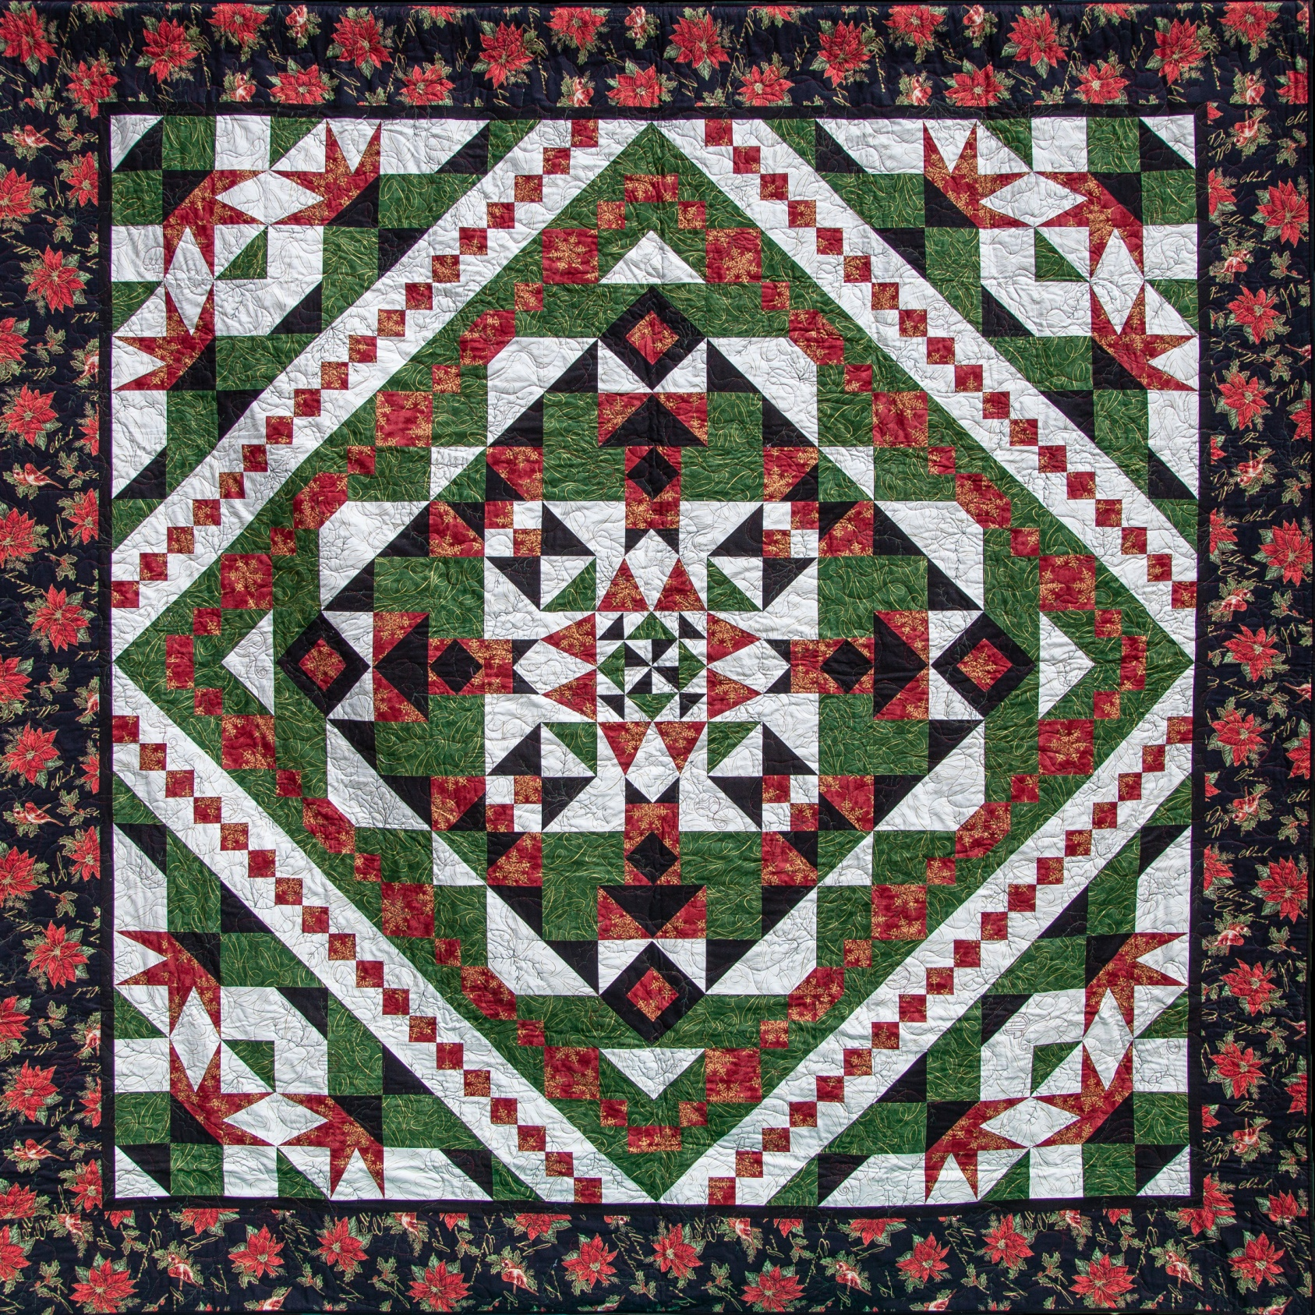
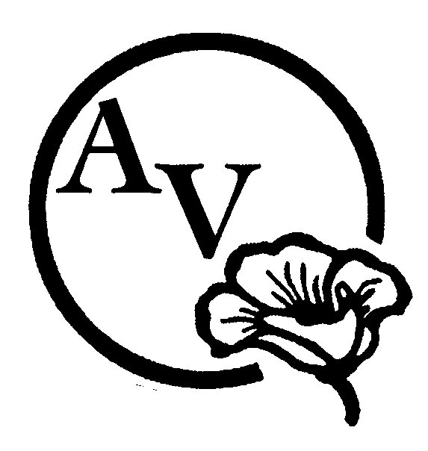

“Desert Blooms”

ENTRANT’s NAME:

Phone Number: Email:

Quilt Title:

Pattern name and/or source:

Size: (Width x Length in inches): Year Completed:

Is this your first time entering a quilt in AVQA? ☐ Yes ☐ No

Construction Technique: Choose one item.

Quilting Technique: Choose one item.

Quilted by:

Quilt available for purchase? ☐ Yes ☐ No
Asking Price:

Comments: Please delete these instructions in red when you write a paragraph and tell us about your quilt! Where did you find the pattern or inspiration? What techniques did you use: What type of thread, batting or embellishment did you use? Does this quilt have a story? What would you like to tell the person who is looking at your quilt?

I have read and understand the Quilt Show Entry Rules. I also understand that liability insurance is the sole responsibility of the entrant. If offering my quilt for sale, I acknowledge that the guild will receive 10% of the asking price.

SIGNATURE OF ENTRANT*: ___________________________________DATE: ___________________
* signature not required if submitted electronically – email transmission will signify agreement.
EMAIL FORM TO: vettequilter@gmail.com
******************************************************************************************************
To be completed by AVQA:

QUILT NUMBER: ________________ JUDGING CATEGORY: ___________________________________________
2019 AVQA QUILT SHOW ENTRY RULES & JUDGING GUIDELINES

1. AVQA MEMBERS current as of January 1, 2019 may enter quilts for judging or exhibition only. AVQA MEMBERS who join after January 1, 2019 may enter quilts for exhibition only.
2. Quilts judged in previous AVQA shows cannot be entered again, except by invitation or exhibition, only.
3. Entrant must be the maker of the entry to be judged.
4. Multiple entries by the same entrant will be hung as space permits.
5. Each quilt entry requires a separate entry form with a photograph attached. The photograph may be of a quilt in progress (unfinished). Photo can be taken at the April meeting during the break.
6. DEADLINE FOR REGISTRATION IS THURSDAY, APRIL 11th. Entry forms will be published in the newsletter and electronic forms will be on the AVQA website. Forms will also be available at Guild meetings. WE NEED YOUR ENTRY FORMS BY APRIL 11TH TO ALLOW US TIME TO PREPARE THE SPREADSHEET, LEGENDS & PROGRAM.
7. Quilts must be finished, clean, and free of odors and pet hair.
8. A four-inch sleeve is required on all quilts except small quilts. Quilts wider than 110 inches cannot be hung on AVQA quilt stands unless folded and draped over the rod.
9. Quilts will have a label sewn on the back with entrant's & quilt's name. Names will be covered for judging.
10. Quilts that are to be judged must be delivered to the Antelope Valley Fair Grounds Friday, May 17, between 8:00 & 9:45 a.m. Exhibit Only quilts may be delivered between 8:00 a.m. & 2:00 p.m. Receipts will be provided with each entry. Alternate check-in arrangements may be made by contacting Sue Jacobsen.
11. The facility will be closed during the "take down" process of the show to all except to those who are working.
12. Quilts may be picked up at the checkout station between 5:00 p.m. and 6:00 p.m. on Sunday, May 19. BRING YOUR RECEIPT. For security purposes, entries may only be removed from the facility through the checkout station.

JUDGED QUILTS
GUIDELINES: Judges reserve the right to move, split, or combine categories dependent on number of entries received.

ART QUILT: Mixed media or fibre art. Art form that uses both modern and traditional quilting techniques to create art objects- “a creative work that is layered and stitched or references a form of stitched layered structure.”

PIECED QUILT: A quilt is considered to be pieced if the piecing is predominant over all other techniques.

APPLIQUÉD QUILT: A quilt is considered to be machine appliqued if both machine and hand applique techniques are used. A quilt is considered to be hand appliqued when ALL of the applique work is done by hand.

MINIATURE QUILT: A traditional quilt pattern that is One-twelfth the size of the standard quilt pattern. A normal 12" finished block will be 1" in Miniature.

BALANCED PIECING & APPLIQUÉ: A combination of appliqué and piecing techniques are used to form the quilt top. Both
techniques must contribute to the over-all design. The quilt must contain a noticeable & significant amount of both.

GROUP QUILT: A quilt with a top that has been constructed by three or more people. Examples of this type of quilt are round robin, block exchange, or a quilt made by a friendship circle.

MODERN QUILT: A 'modern quilt' is a quilt inspired by modern design, including some of the following characteristics: the use of bold colors and prints, high contrast and graphic areas of solid color, improvisational piecing, minimalism, expansive negative space, and alternate grid work; can include 'modern traditionalism or the updating of classic quilt designs.

SPECIALTY TECHNIQUES: Machine or hand quilted entries using predominantly specialty techniques such as cross stitch, embroidery including redwork, stenciling, painting, trapunto, whole cloth, crazy quilting, cathedral window, yo-yo, and rag quilts. This includes quilts that do not fit into the Applique or Pieced categories, and include quilts made using innovative techniques of construction, design and embellishment such as used in pictorial quilts, abstract quilts, snippets, collage, and quilts of original design using innovative piecing or applique techniques.

OTHER: Wearable art, pillows, placemats, table runners, tree skirts, Christmas stockings, sewing machine covers, and tea cozies, etc. The item must contain recognizable quilting.

FIRST TIME ENTRANT: This is the first time the member has entered a quilt for judging in an AVQA quilt show.

* If you have questions regarding categories, contact Sue Jacobsen (vettequilter@gmail.com, text or phone 661-609-8326)

